Drumblade Nursery
Newsletter term 2 – October 2017
Hello and welcome to everyone. If you have any questions/feedback please feel free to approach a member of staff. At Drumblade Nursery, our vision is Friendly, Welcoming, Inspire, Learn to Realise Potential.
Focus
This term we are going to be discussing with the children about some of the life skills that they need within their world. This will include handling money, understanding the purpose of certain tasks (honesty, compassion) and enhancing their knowledge of preparation and delivery of snacks. We also have a focus on “Seasons” including hibernation, light/dark, and nature. The children can lead the learning on from this through our responsive planning; they will guide us on their learning journey.
Health and Wellbeing Indicators
Following on from last term, learning about Health and Well Being Indicators, we would like you to ask the children daily what they have done that would relate to the word we are looking at that week. You will find the weekly words on the main whiteboard. We are encouraging the new language to be used within their communicating skills.
Ask me how to sing….
“Isn’t it funny how a bear likes honey…”
“Scurry Squirrels and don’t be slow…”
“Feed, feed, feed the birds…”
“I see shadows…”
School Activities
We will be continuing to join the school with the “Daily Mile” an incentive for improving health and well-being for the children. We are using the pitch for taking part, joining with the whole school once a week. The children will be actively involved with choosing creative ways to do this.
Dates for your diary:
8-11-17
The Bin Forest Outdoor Session 9:30am-11:45am.
Drop off and collection at the woods car park. We will be having an outdoor session, den making, making creations using clay and tree rubbings..
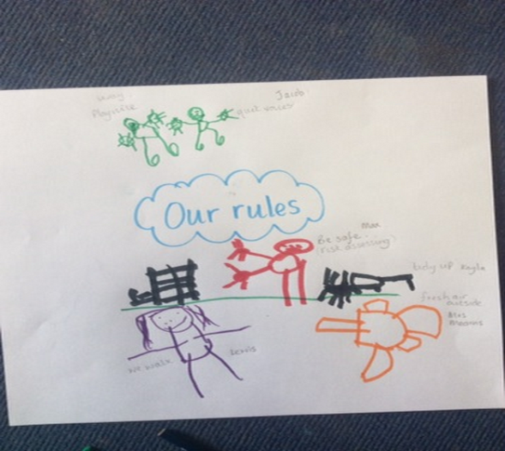
13-11-17 & 14-11-17
In-service days
We have been gathering our ideas and feelings about what should be included in our Nursery charter. You will find our final choices on the main door entering the nursery room.
The UN Convention on the Rights of the Child.

17-11-17
Children in Need - Come dressed wearing something Spotty.
W/C 27-11-17
Parent Interviews
If you would like to have an interview with your child’s key worker, please contact them to arrange a convenient time for you both to be held throughout this allocated week..
29-11-17
Posting our letters to Santa, Book Bug Session and Deans 9:30am – 12:00pm
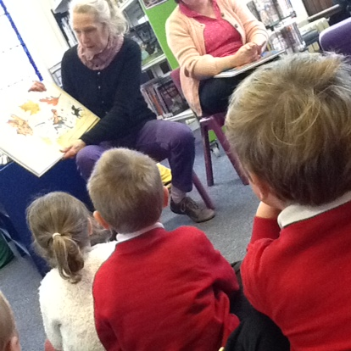
Drop off at post office & collection at Deans Café. We will be looking for books relating to winter and finishing off with snack at Deans.
4–12-17 – 8-12-17
Enterprise Week - More to follow
12-12-17
Christmas Concert – times to follow.
13-12-17
Nursery Christmas Party – more to follow.
15-12-17
Christmas Jumper Day – more to follow.
The children were engaged with the local librarians at our recent trip to the Library. They were read a story about autumn and a bear in the woods. They then freely searched for books to take back to nursery.
I explore and discover the interesting features of my local environment to develop an awareness of the world around me. SOC 0-07a
18-12-17
Carols by Candlelight - more to follow.

“excite” “engage” “explore” “enhance” “extend”
“This is how we do it”
Kirstine Beeley
Parent Sessions
We have put up a planner on the notice board for you to have an option to come in a day (not mandatory) for a session and play. This is to support the parent links with the nursery and staff.. Do not worry if you miss out the dates this term, there will be more added for next term.

Sessions
For all those not attending x5 sessions per week; if you would like to increase your sessions please see Mrs Mearns to discuss.
Feedback
We welcome suggestions/comments/queries from you at any time. There are many ways you can feedback to us, via email, text (mobile), telephone call, arranged meeting, or verbally. If you wish to be kept anonymous, please feel free to leave a note comments box on the storage unit in the corridor. Please also remember to use your profiling system to celebrate achievements from home, comments and observations. If you would like to discuss this further please see Mrs Mearns.
Reply slip
Childs Name:
Will be attending the planned trip to the woods. Yes/No
Reason if not able to come - ___________________________________________________________________________
Will be attending the planned trip to the library. Yes/No
Reason if not able to come - ___________________________________________________________________________
Parents Name:

Please feel free to reply via email.

